***Requirements Analysis***

***Lecture # 12***

***Recap of Requirements Elicitation:***

* Requirements elicitation deals with discovering requirements for a software product
* It is an iterative process and consists of many activities including establishing objectives, understanding background, organizing knowledge, and collecting requirements
* Introduced the concept of elicitation and requirements elicitation process
* Basics of knowledge acquisition (reading, listening, asking, & observing)
* Knowledge acquisition techniques (individual, group, modeling, cognitive)
* Elicitation problems (scope, understandability, volatility)
* Context (organization, environment, project, constraints imposed by people)
* Guidelines for knowledge acquisition
* Discussed in detail some requirements elicitation techniques, especially interviews

***Requirements Engineering Process:***

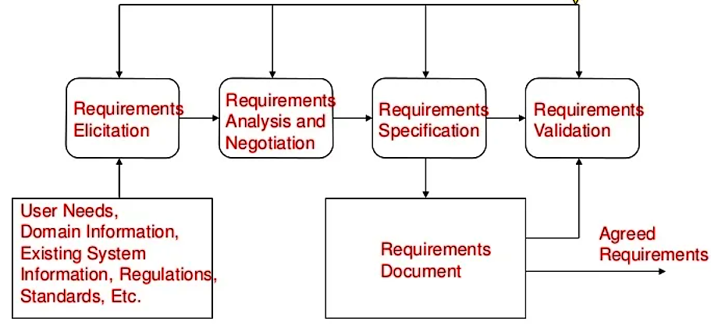

***Requirements Analysis and Negotiation:***

* We’ll discuss requirements analysis and negotiation separately, in order to understand them clearly and to appreciate that different skills are needed to perform them
* They are inter-leaved activities and join to form a major activity of the requirements engineering process

***Requirements Analysis:***

* The aim of requirements analysis is to discover problems with the system requirements, especially incompleteness and inconsistencies
* Some analysis is inter-leaved with requirements elicitation as problems are sometimes obvious as soon as a requirement is expressed
* Detailed analysis usually takes place after the initial draft of the requirements document is produced
* Analysis is concerned with incomplete set of requirements, which has not been discussed by stakeholders

***Iterative Aspects of Elicitation, Analysis, and Negotiation:***

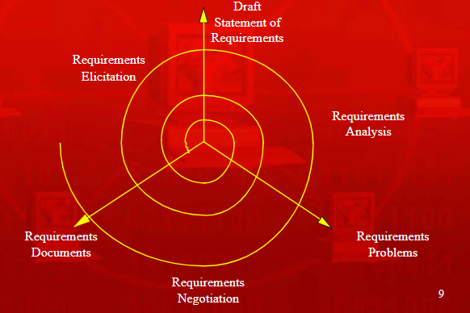

***Comments on Requirements Analysis***

* Analysts read the requirements, highlight problems, and discuss them in requirements review meetings
* This is a time-consuming and expensive activity
* Analysts have to think about implications of the draft statements of requirements
* People do not think in the same way and different analysts tackle the process in different ways
* It is not possible to make this activity a structured and systematic process
* It depends on the judgment and experience of process participants

***Requirements Analysis Stages***

* Necessity checking
* Consistency and completeness checking
* Feasibility checking

***Necessity Checking:***

* The need for the requirement is analyzed. In some cases, requirements may be proposed which don’t contribute to the business goals of the organization or to the specific problem to be addressed by the system

***Consistency and Completeness Checking:***

* The requirements are cross-checked for consistency and completeness. Consistency means that no requirements should be contradictory; Completeness means that no services or constraints which are needed have been missed out

***Feasibility Checking:***

* The requirements are checked to ensure that they are feasible in the context of the budget and schedule available for the system development

***Requirements Analysis Process***

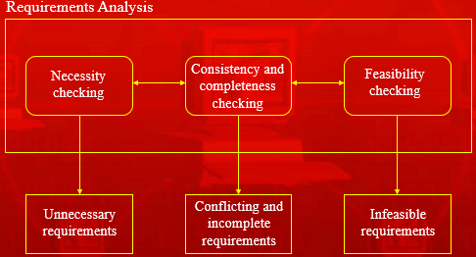

***Analysis Techniques***

***Analysis checklists:***

* A checklist is a list of questions which analysts may use to assess each requirement

***Interaction matrices:***

* Interaction matrices are used to discover interactions between requirements and to highlight conflicts and overlaps

***Analysis Checklists:***

* Each requirement may be assessed against the checklist
* When potential problems are discovered, these should be noted carefully
* They can be implemented as a spreadsheet, where the rows are labeled with the requirements identifiers and columns are the checklist items
* The are useful as they provide a reminder of what to look for and reduce the chances that you will forget some requirements checks
* They must evolve with the experience of the requirements analysis process
* The questions should be general, rather than restrictive, which can be irrelevant for most systems
* Checklists should not include more than ten items, because people forget items on long checklists reading through a document

Example of analysis checklist

***Checklist Items***

* Premature design
* Combined requirements
* Unnecessary requirements
* Use of non-standard hardware

***Checklist Items Description***

***Premature design:***

* + Does the requirement include premature design or implementation information?

***Combined requirements:***

* + Does the description of a requirement describe a single requirement or could it be broken down into several different requirements?

***Unnecessary requirements:***

* + Is the requirement ‘gold plating’? That is, is the requirement a cosmetic addition to the system which is not really necessary

***Use of non-standard hardware:***

* + Does the requirement mean that non-standard hardware or software must be used? To make this decision, you need to know the computer platform requirements

***Checklist Items***

* Conformance with business goals
* Requirements ambiguity
* Requirements realism
* Requirements testability

***Checklist Items Description***

***Conformance with business goals:***

* + Is the requirement consistent with the business goals defined in the introduction to the requirements document?

***Requirements ambiguity:***

* + Is the requirement ambiguous i.e., could it be read in different ways by different people? What are the possible interpretations of the requirement?

***Requirements realism:***

* + Is the requirement realistic given the technology which will be used to implement the system?

***Requirements testability:***

* + Is the requirement testable, that is, is it stated in such a way that test engineers can derive a test which can show if the system meets that requirement?

***Summary***

* Discussed requirements analysis, which is an iterative activity and checks for incomplete and inconsistent requirements
* Studied analysis checklists, and will continue our discussion of requirements analysis in the next lecture
* We’ll talk about requirements negotiation also in the next lecture